- Purpose
The purpose of this document is to describe how EPIC Central interacts with the ClearView system and its interrelationships.
- Scope
The scope of this document is limited to a broad description of EPIC Central and how it interacts with the ClearView system. Further specific details are located in the requirements and specifications documentation.
- Definitions
SaaS | Software as a Service – A common term used to describe software systems that are accessed through a browser and reside on servers in a different physical location from the client. Typical SaaS examples are Salesforce.com, Google Docs, etc.
EDI | Electronic Data Exchange – The transfer of data through electronic means (data files) from one location to another.
https | This is a combination of the Hypertext Transfer Protocol with the SSL/TLS protocol to provide encrypted communication and secure identification of a network web server. HTTPS connections are often used for payment transactions on the World Wide Web and for sensitive transactions in corporate information systems.
Web Service | A web service is typically an application programming interface (API) that is accessed via Hypertext Transfer Protocol (HTTP) and executed on a remote system hosting the requested service.
License Key | File containing a value or string that represents the capabilities of the software. This string is always encrypted.
Encryption | Modifying human readable text into a format that is not readable without performing a conversion.

- System Overview
The ClearView system can be termed a hybrid SaaS enterprise application. The core system is made up of both a fully independent client/server based medical device application delivered to the location of physical use, as well as a SaaS application available via the web that serves to provide authentication, update and control services for the application.
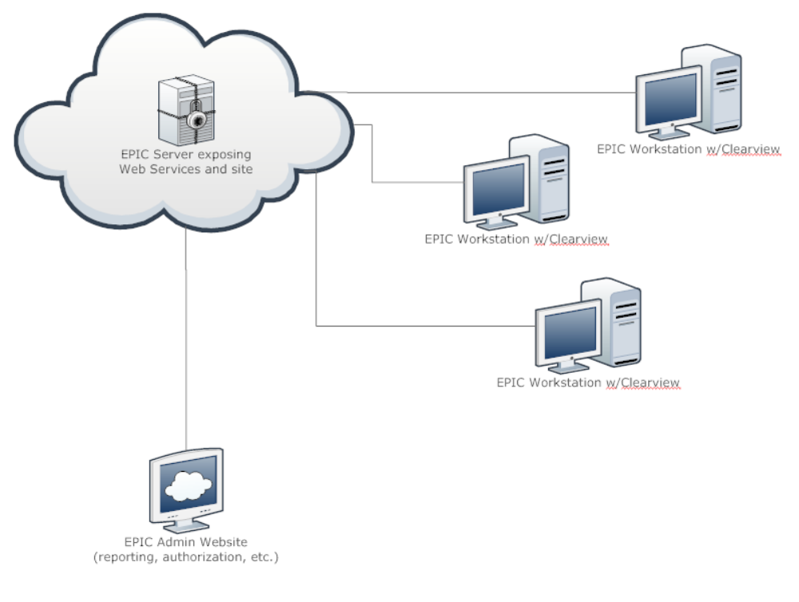
The SaaS based portion of the enterprise application is known internally and in associated documents as EPIC Central. The ClearView system can function without access to EPIC Central, but only for a prescribed amount of time. This limitation is selectively imposed in order to help ensure that the systems are used in an appropriate manner and relatively tight control on the systems is maintained.
EPIC Central is accessible to both EPIC administrators (EPIC support staff) as well as end users (customers). The functionality exposed to each user type is different and determined at time of login.
4.1 Authentication and accessibility
Each ClearView system requires a set of license keys installed into the system in order for it to perform scans. These keys are confirmed each time the system is accessed and used through the use of web service calls to EPIC Central. Requests are sent to EPIC Central each time a scan is performed to determine if the combination of the Client, Location and Device are in fact licensed and assigned to the given customer. This gives EPIC complete control over the use of the device to ensure proper, efficient and effective use of the system.
4.2 Security
All communication between ClearView and EPIC Central is only done over a secure and encrypted connection. If a secure connection cannot be established, the requests are queued and made at a time when a secure connection is established.
4.3 Auditing
The EPIC Central system keeps track of the customer’s transactions and usage. Each time a scan is performed, calibration completed, scan loaded, or user logs in, a message is sent to EPIC Central and tracked. A real time view is available in EPIC Central for EPIC administrators and support personnel to monitor system activity on a 24/7 basis if necessary.
When the computers that the ClearView system is installed on are running, they “ping” EPIC Central at a defined frequency allowing EPIC to monitor existing installations and network activity.
4.4 Backup
ClearView systems use the EPIC Central system as a mechanism to back up client scans and scan results. The ClearView system, after each scan, attempts to pass the collected images and scan calculation results to EPIC Central for safe keeping. The information is sent up through an encrypted connection. The information is referenced by a unique key that contains no personal information.
4.5 Troubleshooting
The EPIC Central system serves as a support and diagnostic system for ClearView. Each time an exception (problem with ClearView) happens, a message containing the relevant information about the issue is automatically sent to EPIC Central. The exception is saved in the EPIC Central system and EPIC engineers are notified if the severity level is of an appropriate level. All of the exceptions can be viewed by EPIC engineers at any time.
The EPIC Central system also contains a support section where users can view their support issues and create new support requests. These queues are accessible to EPIC engineers.
4.6 Self Service
Users are given a login to the EPIC Central system where they can perform a number of actions. These actions include, but are not limited to:
- Purchase more scans
- Update their account information
- View their support issues
- View undelivered messages
- View their scan history
- Retrieve license keys
EPIC Central is designed to be the central communication point between the customer and the company.
4.7 Communication
Messages are automatically created by EPIC Central and queued to be retrieved by the ClearView systems. These messages include but are not limited to:
- Down time (maintenance) notifications
- Quota messages
- Upgrade notifications
These messages are created either through automated system processes running on EPIC Central, or by EPIC engineers. These messages remain at EPIC Central until they are deleted by the user or retrieved by the ClearView application.
4.8 Redundancy
Although ClearView use requires availability of an internet connection during typical use, there is a mechanism built into the application to handle situations where the ClearView application is either unable to obtain internet access, or EPIC Central is unavailable.

Document Revision History
Version Number: | Description of Change: | Date: | Updated by:
000 | New Document | 10/20/11 | A. Mason

